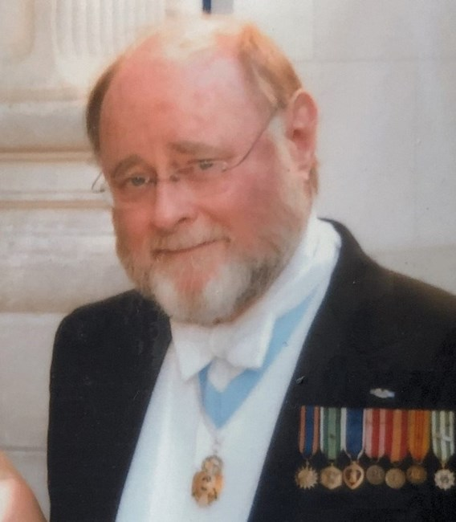
Richard Bender Abell of Fort Belvoir, Virginia, died November 21 at INOVA Mt. Vernon Hospital in Alexandria, VA. He had been a member of the Federal judiciary for twenty years from which he retired. He was married to the former Lucía del Carmen Lombana-Cadavid of Medellín, Colombia.
Born in Philadelphia, Pennsylvania, to Lon Edward Welch, Jr., of Birmingham, Alabama, and Charlotte Amelia Bender of Philadelphia, Pennsylvania. Mrs. Welch divorced and remarried to Ernest George Abell of Philadelphia.
Judge Abell graduated from The George Washington University with a B.A. in 1966 and a J.D. in 1974. He served as a Peace Corps volunteer from 1967 to 1969 in Colombia, South America. Subsequently he volunteered for the U.S. Army and served in Viet-Nam in the 2nd Battalion, 7th Cavalry, 1st Air Cavalry Division in 1970. He was awarded the Purple Heart, the Army Commendation Medal for Heroism, and the Combat Infantryman=s Badge. He was retired from service in 1971 for wounds received in action.
He served as an Assistant District Attorney and Deputy Sheriff in Chester County, Pennsylvania, taught law school at Delaware Law School in Wilmington, Delaware, and was on the U.S. Senate staff of Sen. Richard Schweiker. He was Chairman of the Young Republican National Federation from 1979 to 1981 and served as a member of the board of directors of Young Americans for Freedom from 1979 to 1982.
During the first two years of the Reagan Administration he served in several executive positions with the Peace Corps in Washington, D.C. From 1983 to 1986 he was a Deputy Assistant Attorney General in the U.S. Department of Justice. In 1986 he was appointed by President Ronald Reagan and confirmed by the U.S. Senate as the Assistant Attorney General for the Office of Justice Programs in the Department of Justice where he served through 1990. In 1991 he was appointed to the Federal judiciary in the U.S. Court of Federal Claims as a vaccine judge/special master from which he retired in 2010.
He was also appointed by President Reagan as a member of the Board of Directors of the Federal Prison Industries Corporation in 1985, a member of the Interagency Task Force on Adoption in 1987, and a commissioner on the Presidential Commission on Agricultural Workers serving from 1988 to 1993. During his tenure as an Assistant Attorney General he served as the Chairman of the National Crime Prevention Coalition, member of the Advisory Board of the National Institute of Corrections, Co-Chairman of the Advisory Committee of the National Center for State and Local Law Enforcement Training, Vice-Chairman of the Research and Development Review Board for the Department of Justice, member of the National Drug Policy Board Enforcement Coordinating Group and Coordinating Group for Drug Abuse Prevention and Health, and as a member of the Federal Coordinating Council on Juvenile Justice and Delinquency Prevention.
He was listed in Who’s Who in America, Who’s Who in American Politics, and Who’s Who in American Law. Judge Abell co-authored two books, Peter Smith of Westmoreland County, Virginia, and Sojourns of a Patriot. He was a member of the Society of the Cincinnati, the Society of Colonial Wars, the Sons of the Revolution, the Order of Indian Wars, the Aztec Club of 1847, and the Sons of Confederate Veterans. Many of his progenitors arrived in Virginia as early as 1632 and in Fairfax County in 1657.
He was a member of Lodge No. 22, F&AM, Alexandria, Virginia. He was Anglican-Catholic by faith, a parishioner of the church of St. Andrew & St. Margaret of Scotland of Alexandria, Virginia. He is survived by his loving wife of 51 years; three children, Mr. David Joseph Abell of Deland, Florida, Mr. Christian Aven Lombana Abell of Midlothian, Virginia, and Mrs. Rachel Mercedes Cadavid Abell Foreman of Islamorada, Florida and ten grand-children.
The family will receive friends on Tuesday, November 26, 2019 from 4-8 p.m. at the Demaine Funeral Home, 520 S. Washington St, Alexandria, VA. A church service will be held on Wednesday, November 27, 2019 at 10 a.m. at St. Andrew & St. Margaret of Scotland, 402 E. Monroe Ave, Alexandria, VA. Interment will occur at Arlington National Cemetery at a later date.
In lieu of flowers memorial donations may be made to the Order of Cincinnati or the Skin Cancer Foundation.

