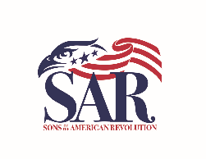

Greetings Compatriots and Friends,

I am happy to welcome you to the Philadelphia Continental Chapter of the Pennsylvania Society of the Sons of the American Revolution. This Guidon was developed to provide information to new members. The current concept is that it will be available online, at PCCSAR.org as well as sending a hard copy to each new member.

Our Chapter represents the four counties of Philadelphia, Delaware, Montgomery and Chester. We have a variety of events during the year including monthly meetings, color guard events and the annual picnic in June. We hope you will join us and become an active member of our Chapter. We have a number of activities which hopefully will fit into your interests.

Like the Chapter website, this Guidon is only of value if it is used and kept up to date. As you use it, I ask that you communicate your assessment to myself and/or the other officers, good as well as not-so-good, meaning an opportunity to improve.
Once again, I welcome you to the Philadelphia Continental Chapter and look forward to getting to meet you at one of our activities.
Fraternally,
Bill Baker
Bill Baker
President
Philadelphia Continental Chapter
Pennsylvania Society
Sons of the American Revolution

